Abstract
Marketing has become highly competitive, with organizations investing heavily in multiple channels such as social media, email marketing, digital advertising, and offline promotions. However, marketing data is often fragmented across different platforms, making it difficult for businesses to evaluate campaign effectiveness accurately. Using tools like MS Excel and Power Query Editor, the data is cleaned, transformed, and structured properly for analysis. A Marketing Campaign Effectiveness Dashboard is created using Power BI to consolidate marketing data into a centralized and interactive analytical platform. The dataset includes important columns like campaign type, channels used, target audience, conversion, return on investment (ROI), acquisition cost, location, clicks, customer segment, engagement score, date and campaign id. The dashboard provides comprehensive insights into campaign performance, channels performance, customer engagement, conversion rates, and return on investment (ROI). By enabling data-driven decision-making, the solution helps organizations optimize marketing strategies, improve budget allocation, and enhance overall campaign performance.
Objective
The main objective of this project is to develop an interactive Power BI dashboard that enables effective monitoring of marketing campaign performance. The dashboard integrates marketing data from multiple sources into a centralized reporting platform, providing a comprehensive view of campaign activities. Through detailed analysis of customer engagement, conversion rates, and overall campaign effectiveness, the dashboard helps identify the most successful marketing channels and campaign types. By delivering meaningful insights into campaign performance, it supports data-driven decision-making for marketing budget allocation and resource optimization. Ultimately, the project aims to enhance marketing strategies, improve customer acquisition and engagement, and drive overall business growth.
Problem Statement
Organizations invest a lot of resources in marketing campaigns across various channels, yet many struggle to measure their effectiveness accurately. Marketing data is typically distributed across platforms such as social media, advertising tools, CRM systems, and web analytics applications, which leads to unified view of campaign performance. Traditional reporting methods often provide only basic metrics and fail to explain the factors driving campaign success or failure. Furthermore, businesses lack the ability to compare performance across campaigns, audience segments, and time periods effectively. The absence of a centralized, interactive analytics solution limits stakeholders' ability to uncover meaningful insights and make informed decisions. Consequently, marketing budgets may be allocated inefficiently, resulting in reduced campaign effectiveness and lower returns on investment. This project addresses these issues by providing detailed and structured analysis.
Proposed System
The proposed solution is a Marketing Campaign Effectiveness Dashboard developed using Power BI. It provides a centralized and interactive platform for analysing marketing performance. Key features include a campaign type comparison to evaluate the effectiveness of different marketing initiatives. The dashboard also offers channel performance evaluation to identify the most successful marketing channels, ROI and conversion analysis by month to track the returns trends over time, acquisition cost for different campaign and its return to evaluate campaign performance, target audience analysis to assess the conversion, and customer segment analysis to understand the behaviour of different customer groups, and geographic performance analysis to measure campaign success across locations. The system allows users to filter data using slicers for better interaction. Visual charts and KPIs are used to represent data clearly. The dashboard is designed to be user-friendly and easy to understand. Overall, the dashboard enables stakeholders to monitor key performance indicators (KPIs), identify trends and opportunities, and make informed decisions to improve marketing effectiveness and optimize resource allocation.
Advantages
The proposed Power BI dashboard improves visibility into marketing performance, enabling organizations to better understand customer engagement and make data-driven decisions that optimize marketing budget allocation and increase return on investment. As a centralized reporting platform, the dashboard offers an interactive and user-friendly interface with automated data refresh capabilities, reducing manual effort and ensuring real-time performance monitoring. Additionally, it supports advanced analytical functions such as cross-channel performance comparison, audience segmentation analysis, trend identification and forecasting opportunities, allowing stakeholders to quickly identify successful marketing strategies and areas for improvement.
Existing System
The existing marketing performance evaluation process largely depends on manual data collection from multiple platforms and static reports generated by individual marketing tools. As no proper analytical tool used, this often provide limited visualization and analytical capabilities, making it difficult to effectively analyse and compare campaign performance. Furthermore, the use of separate reporting systems for different marketing channels results in fragmented data and a lack of a unified view of overall marketing activities. Consequently, organizations face challenges in obtaining comprehensive insights, while report preparation requires considerable time and effort, reducing the efficiency of decision-making processes.
Disadvantages
The current system has several disadvantages that causes businesses to struggle to accurately evaluate the effectiveness of their campaigns and understand the true return on investment. Data is often fragmented across multiple platforms, making it difficult to obtain a comprehensive view of campaign performance. The reliance on manual report generation is time-consuming and increases the risk of human errors during data consolidation. Additionally, limited real-time monitoring and analytical capabilities make it challenging to identify the factors influencing campaign success and compare performance across different channels and time periods. These shortcomings can lead to less informed decision-making and inefficient allocation of marketing budgets and resources.
Modules Used
- Dataset from Kaggle (Marketing Campaign Effectiveness data)
- Columns: Campaign Type, Channels Used, Target Audience, Conversion, Return on Investment (ROI), Acquisition Cost, Location, Clicks, Customer Segment, Engagement Score, Date and Campaign Id.
- Tool used: MS Excel 2021 & MS Power BI
- Data cleaning: MS Excel 2021 Power Query
- Data processing: unwanted column removal & format change
- Analysis: MS Power BI
- Visualization: Charts & Graphs
Methodology
The project follows a structured methodology to ensure accurate results. First, the dataset is collected from Kaggle. Then, the data is imported into Excel for processing. Data cleaning is performed using Power Query Editor to address changes in currency format for Conversion, Return on Investment (ROI), Acquisition Cost, Clicks and Date columns, and removal of unwanted columns Company, Duration, Impression and Language. The cleaned data is then imported to MS Power BI to analyse the data. Charts and visualizations are created for better understanding. A dashboard is designed to display all insights in one place. Filters and slicers are added for user interaction. Finally, the dashboard is tested and finalized for use. To achieve the project objectives, several analytical components are incorporated into the dashboard. Campaign type comparison is performed to evaluate the effectiveness of different marketing initiatives. The dashboard also offers channel performance evaluation to identify the most successful marketing channels, ROI and conversion analysis by month to track the returns trends over time, acquisition cost for different campaign and its return to evaluate campaign performance, target audience analysis to assess how customer demographic influence conversion, and customer segment analysis to understand the behaviour of different customer groups, and geographic performance analysis to measure campaign success across locations. This enables the businesses to accurately evaluate the effectiveness of their campaigns and understand the true return on investment.
Conclusion
The Marketing Campaign Effectiveness Dashboard addresses the challenges associated with fragmented marketing data and limited analytical capabilities. By integrating data from multiple sources into an interactive Power BI environment, the solution provides meaningful insights such as best performing campaign, best conversing channels, month that gives high and low return. It is also identified that campaign with high acquisition cost do not necessarily gives high return of investment. High-value customer segments. location and target audience that gives high return were also successfully identified. The dashboard enables organizations to make informed decisions, optimize marketing strategies, and allocate resources more efficiently. Ultimately, the project contributes to improved marketing effectiveness, enhanced business performance, and greater return on investment through data-driven decision-making.
Result
The implementation of the Marketing Campaign Effectiveness Dashboard achieves its objectives by providing a comprehensive and centralized view of campaign performance across multiple marketing channels. The dashboard successfully identifies top-performing campaigns and channels, enabling organizations to evaluate which strategies generate the highest returns. It facilitates the comparison of key performance indicators such as ROI, conversion rates, and engagement metrics, allowing businesses to better understand campaign effectiveness. By delivering clear and actionable insights, the dashboard supports informed strategic decision-making and helps optimize marketing efforts. Additionally, the automation of reporting processes significantly reduces the time required for data analysis and report generation. Overall, organizations can leverage these insights to improve marketing effectiveness, optimize resource allocation, and maximize returns on their marketing investments.
Future Improvement
The project can be further enhanced through the integration of live marketing APIs for real-time analytics, predictive analytics and machine learning for trend forecasting, and campaign performance prediction capabilities. Additional features such as Customer Lifetime Value (CLV) analysis, automated budget optimization recommendations, and advanced customer journey mapping would provide deeper insights into customer behaviour and marketing effectiveness. These improvements would further strengthen strategic decision-making and enhance overall organizational performance.
Output
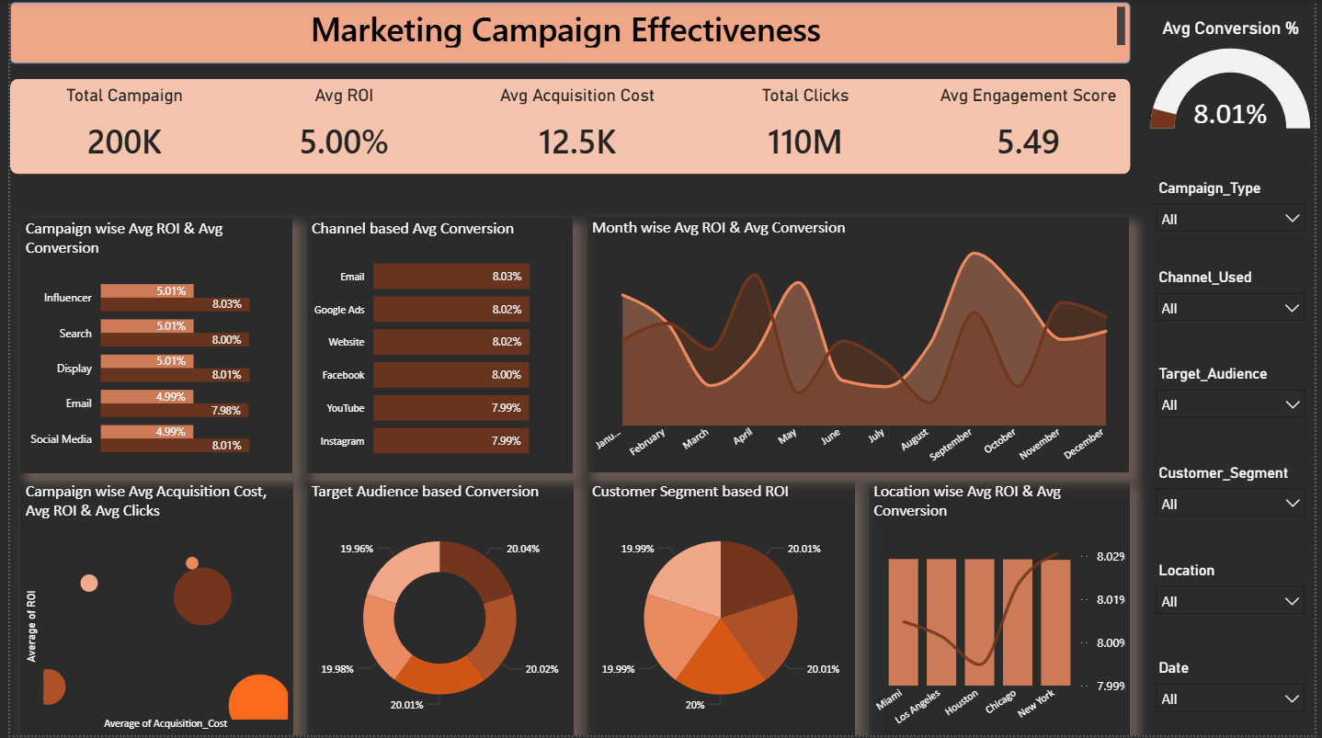

Reference
- Marketing campaign effectiveness: analysing the effectiveness of different types of marketing campaigns in various channels, examining metrics such as engagement rates, impression, clicks, and Roi, June 2024, DOI:10.13140/RG.2.2.31301.26082, Dikshita Das.
- Analyzing marketing campaign effectiveness: a comparative approach using traditional and online data analysis methods, August 2024 DOI: https://doi.org/10.13166/jms/191165, Krzysztof Król, Tomasz Sidor, Anna Wiśniewska, Emanuel Józefacki, Bartłomiej Bartnik .
- Evaluating the Effectiveness of Advertising Campaigns in the Fast-Food Industry Using an Analytical Engine, May 2024, https://ersj.eu/journal/3393/download/Evaluating+the+Effectiveness+of+Advertising+Campaigns+in+the+FastFood+Industry+Using+an+Analytical+Engine.pdf , Paweł Rymarczyk, Cezary Figura, Łukasz Wojciechowski, Kamila Ćwik, Piotr Staliński.
- The Experimental Study on the Effectiveness of Social Media Ad Campaign: Like, Comment, Share, June 2019, DOI:10.22555/ijelcs.v4i1.2452.g535, Sania Usmani, Syed Fawaz Ali, Kiran Imtiaz, Hamza Ghani Khan.
- Effectiveness of Digital Marketing Activities: A Review of Key Challenges, Benefits and Opportunities, February 2025, DOI:10.1007/978-3-031-71649-2_75, Reem Fahad Alkhalfan, Muneer Al Mubarak.

